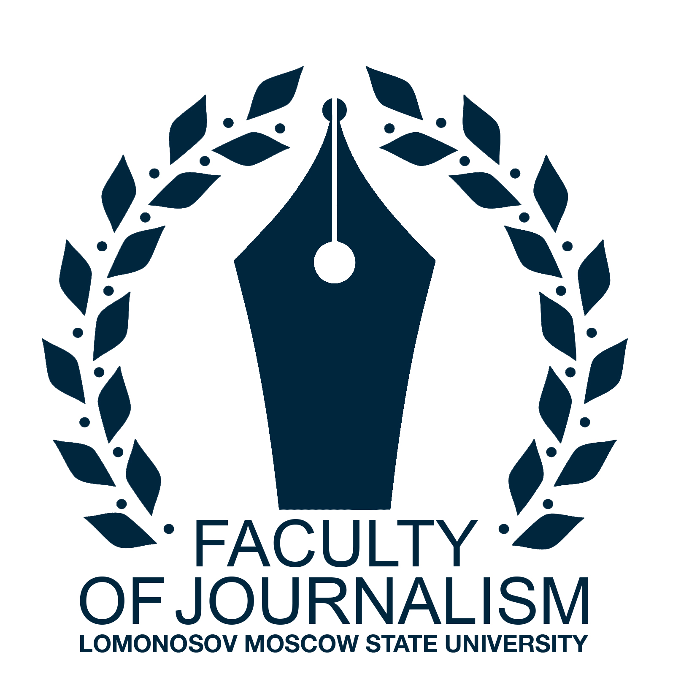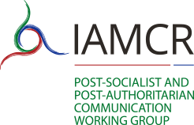

The 11th International Media Readings in Moscow
‘Mass Media and Communications-2019’

DIGITALIZING MEDIA:
COMMUNICATION, AUDIENCES, POLICIES

www.moscowreadings.com
moscow.readings@mail.ru

Dates: 17-18 October 2019
Languages: English, Russian
Organizer: Faculty of Journalism, Lomonosov Moscow State University
In partnership with: IAMCR Digital Divide Working Group, IAMCR Post-Socialist and Post-Authoritarian Communication Working Group, UNESCO chair in communication, National Association of Mass Media Researchers
Venue: Faculty of Journalism, Lomonosov Moscow State University (Moscow, Mokhovaya street, 9)
Local organizing and program committees are headed by Professor Elena Vartanova, Dean of the Faculty of Journalism, Lomonosov Moscow State University, Corresponding member of the Russian Academy of Education, President of the National Association of Mass Media Researchers

The process of media digitalization has significantly influenced communication practices and media systems in both national and global contexts. Today, there is a clear shift towards digital communication, with new channels, platforms, players, distribution and delivery opportunities constantly developing. As an effect of these processes, we can observe changes in media production and media consumption; growing popularity of digital media compared to the traditional media, and the gradual shift of the latter towards digital formats (digital broadcasting, appearance of online versions of print media, etc.); transformations in audience behavior and the growing need for media and digital literacy; changes of media policy and regulation instruments, logics and formats, and many other effects. There also remain some challenges that many countries across the world are facing today: the problem of digital exclusion and digital inequalities, unequal digital engagement of various social/cultural/ethnic groups, information security issues, deprofessionalization of the journalistic work, fake news/post-truth challenges, etc.
Questions for discussion
- Communication in the digital age: practices, tendencies, challenges;
- Mobile media and communication;
- News media as gatekeepers, critics and facilitators;
- Mass media and audience: a shift from mass communication to more fragmented and individualized forms of media;
- Fake news / post-truth challenges;
- Media literacy in the digital age;
- Digital natives: media consumption and media production practices;
- New players and actors in digital communication;
- Digital inclusion / social inclusion: correlations and interdependencies;
- Digital inequalities in the societies across the globe;
- Multicultural/multiethnic societies and digital engagement;
- Policies against divides, distrust and discrimination;
- Information security in the digital age;
- Coverage of EU elections-2019 in the traditional and digital media

Special sections
‘Digital, social and cultural divides: interrelations and interdependencies’ organized by IAMCR Digital Divide Working Group;
‘Media and communication in post- and neo-authoritarian societies: global trends, local formats’ organized by IAMCR Post-Socialist and Post-Authoritarian Communication Working Group;
‘Fifteen years of ‘Comparing Media Systems’ book: theoretical legacy in the new digital world’ (in celebration of 15 years of ‘Comparing Media Systems: Three Models of Media and Politics’ book by Daniel C. Hallin and Paolo Mancini, first published in 2004)
Submissions to the special sections should be sent as regular submissions. Please add a note in your abstract saying that this submission should be considered by a particular special section (title).

Confirmed keynote speakers
Prof. Dr. Elena Vartanova, Lomonosov Moscow State University (Russia)
Prof. Dr. Mark Deuze, University of Amsterdam (The Netherlands)
Prof. Dr. Josef Trappel, University of Salzburg (Austria)
Prof. Dr. Gianpietro Mazzoleni, University of Milan (Italy)
Dr. Massimo Ragnedda, Northumbria University Newcastle (Great Britain)
Other keynote speakers to be confirmed

Registration form should include:
- Full name;
- Name of institution;
- Position, title;
- Phone number, e-mail;
- Abstract (between 300 and 500 words) in .doc or .docx in English or Russian

Registration form and abstract should be sent by e-mail to moscow.readings@mail.ru before 15 August 2019

Registration fee
Moscow Readings conference does not have conference registration fee, although all costs (travel, accommodation, visa, etc.) will have to covered either by the home institution or by the presenters themselves. We are sorry to say that we do not provide any grant support or any other financial assistance to conference participants either.

Publishing opportunities
Best papers will be considered for publication in peer-reviewed Vestnik Moskovskogo universiteta. Seriya 10. Zhurnalistika, the leading journal in media and communication fields in Russia. The journal is included into the database of the best Russian journals RSCI (Russian Science Citation Index), basing on the Web of Science platform. Best papers will also be considered for publication in World of Media. Journal of Russian Media and Journalism Studies, international peer-reviewed journal published in Russia. Both issues should be out in 2020. Information on other publishing opportunities will be available shortly.

Contact details
Contact email: moscow.readings@mail.ru
Phone number : +7 (495) 629 52 76
Postal and visiting address: 125009 Mokhovaya street 9, Moscow, Russia
Contact person: Anna Gladkova, secretary of the Moscow Readings organizing committee

