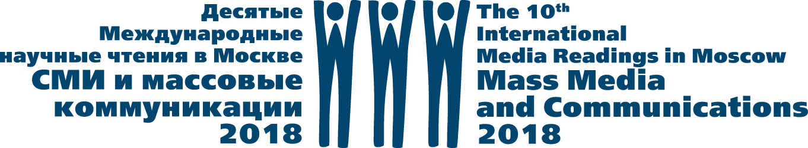

The 10th International Media Readings in Moscow
“Mass Media and Communications-2018”

DIGITAL TRANSFORMATIONS OF MASS MEDIA:
REGIONAL, NATIONAL AND GLOBAL ASPECTS

www.moscowreadings.com
moscow.readings@mail.ru

Dates: 25-26 October 2018
Working languages: English, Russian
Organizer: Faculty of Journalism, Lomonosov Moscow State University
Local organizing and program committees are headed by Professor Elena Vartanova, Dean of the Faculty of Journalism, Lomonosov Moscow State University, Corresponding member of the Russian Academy of Education, President of the National Association of Mass Media Researchers

Today, media everywhere in the world undergo significant transformations under the influence of digitalization, media convergence, mediatization of the society, deprofessionalization of journalistic work, the development of new active audiences which take over some functions that have been traditionally performed by journalists, and other processes. These transformations include changes in media genres and topics, forms and methods of professional journalistic activities, economic strategies and business models, distribution and delivery channels, specifics of audience behavior and other aspects.
Given such noticeable transformations of media, we encourage conference participants to discuss current state of media and look into possible trends of media industry’s development in both global and national contexts. Furthermore, we invite presentations discussing the state of regional and local media in Russia, media production and distribution processes abroad and other issues that have rarely been in the spotlight of researchers before. Lastly, we welcome researches discussing the impact of television upon print media as well as new media under current digitalization process.

Questions for discussion:
- History and current trends of media development;
- Regulation and self-regulation of media;
- Mass media and audience: the shift from mass communication to specialized media;
- Values and mission of mass media;
- Mass media in the digital era: current challenges and prospects;
- Newspapers and magazines in digital environment: issues of interaction and mutual influence;
- Regional and local media in Russia: current state and trends of development;
- Journalism education and modern media: goals, challenges and prospects in the new digital era

Registration form should include:
- Full name;
- Name of institution;
- Position, title;
- Phone number, e-mail;
- Abstract (up to 500 words) in .doc or .docx in English or Russian

The registration form and abstract should be sent by e-mail to moscow.readings@mail.ru before 15 August 2018

All questions can be addressed to the Local Organizing Committee:
Postal and visiting address: 125009 Mokhovaya street 9, Moscow, Russia
Contact email: moscow.readings@mail.ru
Contact phone number: +7 (495) 629 52 76
Contact person: Dr. Anna Gladkova, Secretary of the Local Organizing Committee

